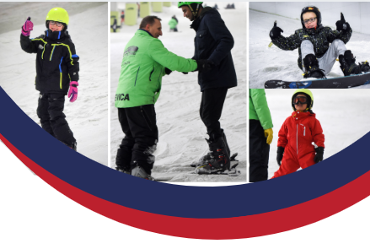

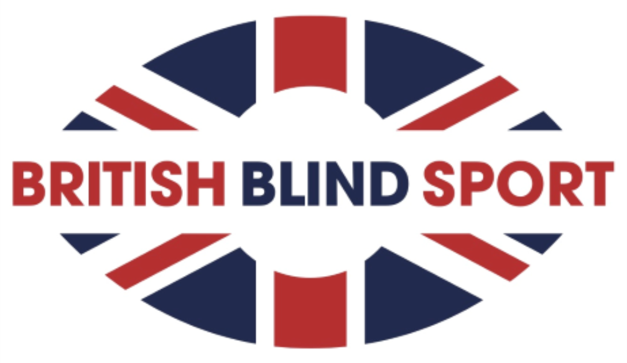

Disability Snowsport UK logo


MANCHESTER

Snow Sports Have a Go Day!

British Blind Sport are running a snow sports taster session for people with a visual impairment and their families and friends at Chill Factore in Manchester!

**Date:** December 13th 2019

**Time:** 6pm - 8pm

**Venue:** Manchester Chill Factore

Meet and Greet is available from Intu Trafford Centre Bus Station.

£10 cost per participant, payable in advance to secure your spot!

Click [**here**](https://britishblindsport.org.uk/manchestersnowsports/) to register you place

**For more information, contact alex@britishblindsport.org.uk or call 01926 424247**

We are grateful to The Worshipful Company of Grocers for supporting us in delivering this event

Registered Charity Number: 1168093 Company Limited by Guarantee Number 10009918